CAMPUS HIRE - CAMPUS PLACEMENT MANAGEMENT SYSTEM

A PROJECT REPORT

Submitted by
BALAAMBIGA C A
(2116240701068)

in partial fulfilment of the End Semester Examination for the course
CB23F35 -
LOW-CODE APPLICATION DEVELOPMENT USING ZOHO CREATOR
In
BACHELOR OF ENGINEERING
COMPUTER SCIENCE AND ENGINEERING



RAJALAKSHMI ENGINEERING COLLEGE
(An Autonomous Institution, Affiliated to Anna University, Chennai)
Rajalakshmi Nagar, Thandalam, Tamil Nadu – 602 105

NOVEMBER 2026
RAJALAKSHMI ENGINEERING COLLEGE
(An Autonomous Institution, Affiliated to Anna University, Chennai)
BONAFIDE CERTIFICATE
Certified that this project report titled “CAMPUSHIRE - CAMPUS PLACEMENT MANAGEMENT SYSTEM” is the bonafide work of BALAAMBIGA C A [2116240701068], who carried out the individual project work on the Zoho Creator Low-Code platform for the course CB23F35 - Low-Code Application Development using Zoho Creator during the academic year 2026 - 2027, Semester 5, under the supervision.

SIGNATURE  Dr. Manoranjini J  HEAD OF THE DEPARTMENT  Department of Computer Science and Engineering  Rajalakshmi Engineering College  Thandalam – 602 105 | SIGNATURE  Dr. Jinu Sophia  COURSE FACULTY  Department of Computer Science and Engineering  Rajalakshmi Engineering College  Thandalam – 602 105

Submitted for the End Semester Examination held on: ______________________________

INTERNAL EXAMINER | EXTERNAL EXAMINER
DECLARATION
I, BALAAMBIGA C A [2116240701068], hereby declare that the project report titled “CampusHire - Campus Placement Management System” submitted for the End Semester Examination of the course CB23F35 - Low-Code Application Development using Zoho Creator, is a record of original work carried out by me individually. The Zoho Creator application described in this report, including its data model, forms, reports, pages, Deluge scripts and workflows, was designed and developed by me.
I further declare that this work has not been submitted, in part or in full, for the award of any other degree or course credit. Every template, sample application, AI-assisted feature (such as Zia or the AI application builder), code snippet or external resource used in this work has been duly acknowledged in the report.

Place: Chennai
Date: ____________________
SIGNATURE OF THE STUDENT
BALAAMBIGA C A
ACKNOWLEDGEMENT

I express my sincere gratitude to our Chairman Thiru. S. Meganathan, Chairperson Dr. (Mrs.) Thangam Meganathan and Vice-Chairman Mr. Abhay Meganathan for providing the infrastructure and facilities that made this work possible.
I am grateful to our Principal Dr. S.N. MURUGESAN, Rajalakshmi Engineering College, for the constant encouragement extended to students to take up industry-relevant learning.
I thank Dr. Manoranjini J, Head of the Department, Department of Computer Science and Engineering for the guidance and support provided throughout the course.
I owe my sincere thanks to my course faculty, Dr. Jinu Sophia, for the valuable guidance, reviews and feedback that shaped this application and report.
I also acknowledge Zoho Creator Education Program for providing access to the Zoho Creator platform and learning resources, and I thank my family and friends for their unwavering support.
BALAAMBIGA C A
ABSTRACT

Campus placement involves many connected activities: collecting student profiles, registering visiting companies, announcing placement drives with eligibility criteria, receiving job applications, scheduling interview rounds and recording results. When these are handled through separate spreadsheets, e-mails and notices, records are repeated, status is unclear, confirmations are forgotten and the placement team has no single view of the process.
CampusHire is designed as a centralised low-code application using Zoho Creator. It organises placement information through five forms: Student Registration, Company, Placement Drive, Job Application and Interview. A lookup field links each placement drive to a registered company, while picklists, multi-select lists, mandatory fields and a resume upload keep records complete and consistent. Six Deluge form workflows send notification e-mails on registration, drive creation, application and interview scheduling, and create a lead in Zoho CRM for every student record.

Nine reports, including full lists and tracking lists sorted by deadline and interview date, and a dashboard page with four count cards, a placement status donut chart and an application status column chart help the placement team review the process at a glance. Status fields on applications, interviews, drives and students provide a simple lifecycle for each record type. The application demonstrates how a low-code platform can turn routine placement coordination into an automated and reviewable system with limited repetitive coding. Test results, live screenshots and production deployment details are marked in this report for verification in the running application.

Keywords: Campus Placement Management; Zoho Creator; Low-Code Development; Deluge Scripting; Workflow Automation; Zoho CRM; Dashboard.
PROJECT AT A GLANCE
Attribute | Details
Project Title | CampusHire - Campus Placement Management System
Application Domain | Campus placement and training-and-placement cell management
Student Name & Register No. | BALAAMBIGA C A [2116240701068]
Course Faculty | Dr. Jinu Sophia
Development Platform | Zoho Creator low-code platform
Application Scope | Student registration, company registration, placement drives, job applications and interviews
Forms | 5 core forms
Automation | 6 form workflows (5 e-mail notifications, 1 Zoho CRM lead creation) implemented with Deluge scripts
Process Control | Status-driven lifecycles for applications, interviews, drives and students (no Blueprint, no scheduled workflow)
Reports | 9 reports (5 default full lists and 4 additional lists)
Dashboard | 4 count cards and 2 charts (placement status donut, application status column)
External Integration Points | E-mail through the Deluge sendmail task; Zoho CRM lead creation
Deployment Status | Application built and exported on 29-Oct-2026 (version 1.0); published URL and production deployment evidence not supplied
TABLE OF CONTENTS
CHAPTER NO. TITLE PAGE NO.
1 INTRODUCTION 12
1.1 Background 12
1.2 Problem Statement 12
1.3 Objectives 13
1.4 Scope of the Project 14
1.5 Justification for a Low-Code Approach 14
1.6 Organisation of the Report 14
2 LITERATURE SURVEY AND SYSTEM STUDY 16
2.1 Study of the Existing System 16
2.2 Limitations of the Existing System 16
2.3 Low-Code versus Traditional Development 17
2.4 Literature Survey 17
2.5 Emerging Trends in Low-Code Development 18
2.6 Proposed System 18
3 REQUIREMENT ANALYSIS 19
3.1 Stakeholders and User Roles 19
3.2 Functional Requirements 19
3.3 Non-Functional Requirements 20
3.4 Hardware and Software Requirements 20
3.5 Use Case Model 21
4 SYSTEM DESIGN 22
4.1 System Architecture 22
4.2 Data Model 22
4.3 Form Design 24
4.4 Process and Workflow Design 24
4.5 User Interface and Navigation Design 25
4.6 Access Control Design 25
5 IMPLEMENTATION 26
5.1 Application Setup 26
5.2 Forms and Data Capture 26
5.2.1 Company Form 25
5.2.2 Student Registration Form 25
5.2.3 Placement Drive Form 26
5.2.4 Job Application Form 27
5.2.5 Interview Form 28
5.3 Reports 29
5.4 Pages and Dashboards 31
5.5 Deluge Scripting 32
5.6 Workflows and Automation 33
6 TESTING AND DEBUGGING 35
6.1 Testing Strategy 35
6.2 Test Cases 35
6.3 Debugging Deluge Scripts 35
6.4 Defect Log 36
6.5 User Acceptance Testing 36
7 DEPLOYMENT, SECURITY AND GOVERNANCE 37
7.1 Environments and Deployment Strategy 37
7.2 Performance Optimisation 38
7.3 Security Features 38
7.4 Governance and Administration 38
8 RESULTS AND DISCUSSION 39
8.1 Application Output 39
8.2 Achievement of Objectives 40
8.3 Comparison with the Existing System 40
8.4 Limitations of the Low-Code Approach 41
8.5 Reflection on the No-Code → Low-Code → Pro-Code Spectrum 41
9 CONCLUSION AND FUTURE ENHANCEMENTS 42
9.1 Conclusion 42
9.2 Future Enhancements 42
9.3 Learning Outcomes and Career Relevance 42
REFERENCES 43
APPENDIX A 44
Feature Coverage Checklist 44
APPENDIX B 45
Reports and Dashboard Catalogue 45
B.1 Reports 45
B.2 Count Cards 45
B.3 Charts 45
B.4 Scheduled Monitoring 45
APPENDIX C 46
Deluge Logic Summary 46
C.1 Job Application Confirmation 46
C.2 Company Registration E-mail 46
C.3 Interview, Drive and Student Notifications 46
C.4 Zoho CRM Lead Creation 46
APPENDIX D 47
User Manual 47
D.1 General Access 47
D.2 Setting Up 47
D.3 Daily Use 47
D.4 Review and Administration 47
D.5 Troubleshooting 47
APPENDIX E 49
Evaluation Rubric 49
APPENDIX F 51
Viva-Voce Record Sheet 51
LIST OF TABLES

Table 1.1: Project Objectives and Measures
Table 2.1: Low-Code and Traditional Development Comparison
Table 2.2: Literature Survey Summary
Table 3.1: Stakeholders and User Roles
Table 3.2: Functional Requirements
Table 3.3: Non-Functional Requirements
Table 3.4: Hardware and Software Requirements
Table 3.5: Use Case Descriptions
Table 4.1: Entities and Relationships
Table 4.2: Form Design Groups
Table 4.3: Access Control Design
Table 5.1: Forms Implemented
Table 5.2: Company Form Fields
Table 5.3: Student Registration Form Fields
Table 5.4: Placement Drive Form Fields
Table 5.5: Job Application Form Fields
Table 5.6: Interview Form Fields
Table 5.7: Reports Implemented
Table 5.8: Deluge Logic Summary
Table 5.9: Workflow Summary
Table 6.1: Test Cases
Table 6.2: Defect and Validation Log
Table 7.1: Deployment Checklist
Table 7.2: Security Controls Implemented
Table 8.1: Objective Achievement Mapping
Table 8.2: Comparison with the Existing System
Table A.1: Feature Coverage Checklist
Table B.1: Scheduled Monitoring
Table D.1: Troubleshooting
Table E.1: Evaluation Rubric for the Individual Project
Table E.2: Performance Level Descriptors
Table F.1: Viva-Voce Questions and Responses
Table F.2: Marks Summary
LIST OF FIGURES

Figure 2.1: Campus placement process represented as the proposed automated workflow
Figure 3.1: Primary actors and the CampusHire application
Figure 4.1: Logical architecture of the CampusHire application
Figure 4.2: Conceptual relationships between core CampusHire entities
Figure 4.3: Application and interview status lifecycles in CampusHire
Figure 5.1: CampusHire application in the Zoho Creator workspace
Figure 5.2: Company form in live mode
Figure 5.3: Student Registration form in live mode
Figure 5.4: Placement Drive form in live mode
Figure 5.5: Job Application form in live mode
Figure 5.6: Interview form in live mode
Figure 5.7: Student Details Report
Figure 5.8: Placement Drive Report
Figure 5.9: Interview Tracking Report
Figure 5.10: CampusHire dashboard
Figure 5.11: Deluge script of the Student Registration Confirmation workflow
Figure 5.12: Workflow configuration of CampusHire
Figure 5.13: Notification e-mail received from CampusHire
Figure 5.14: Lead created in Zoho CRM
Figure 6.1: Workflow execution history
Figure 7.1: Environments
Figure 8.1: Scenario Step 1 – Registering a student
Figure 8.2: Scenario Step 2 – Student record in the report
Figure 8.3: Scenario Step 3 – Notification e-mail received
Figure 8.4: Scenario Step 4 – Dashboard updated with counts and charts
LIST OF ABBREVIATIONS
Abbreviation | Expansion
API | Application Programming Interface
CGPA | Cumulative Grade Point Average
CRM | Customer Relationship Management
CRUD | Create, Read, Update and Delete
ER | Entity–Relationship
LCAP | Low-Code Application Platform
LPA | Lakhs Per Annum
PII | Personally Identifiable Information
RBAC | Role-Based Access Control
UAT | User Acceptance Testing
UI | User Interface
URL | Uniform Resource Locator

CHAPTER 1
INTRODUCTION

1.1 Background
Campus placement is one of the most important activities of an engineering college. Every year the training and placement cell must collect student details, register visiting companies, announce placement drives, receive applications, schedule interview rounds and finally record who was selected. In many colleges these activities are handled through separate spreadsheets, e-mail threads, notice boards and messaging groups. Student profiles are kept in one file, company contacts in another, and the status of every application has to be tracked by hand.
When information is scattered in this way, the same details are typed again and again, eligibility criteria such as the minimum CGPA and required skills are checked manually, and students may not receive timely confirmation of their applications or interviews. A centralised and automated tool reduces this effort by capturing every record once, linking it to the right company or drive, and notifying the concerned people when something is submitted.
CampusHire is a campus placement management application developed on the Zoho Creator low-code platform. It brings student registration, company registration, placement drives, job applications and interview tracking into one application, uses Deluge workflows to send e-mail notifications, creates a lead in Zoho CRM for every registered student, and gives the placement team reports and a dashboard of key indicators.

1.2 Problem Statement
Managing campus placements through separate spreadsheets, e-mails and messages makes it difficult to keep student, company and drive records consistent and to act on them in time. Missing student information, unclear application status and the absence of a consolidated overview reduce the efficiency of the placement cell and the experience of the students.
- Student profiles, resumes, skills and CGPA are stored in different files, so there is no single searchable record of every student.
- Company details and placement drives are announced through notices and messages, and eligibility conditions are not stored in a structured form.
- Job applications and interview rounds are tracked manually, so the current status of a student is hard to find.
- Confirmation messages for registrations, applications and interviews are sent by hand and are easily forgotten.
- The placement team has no ready summary of registered students, companies, drives, interviews, placement status and application status.

1.3 Objectives
- Design structured data forms for students, companies, placement drives, job applications and interviews.
- Capture a complete student profile including CGPA, skills, certifications, projects, backlogs and resume.
- Automate e-mail notifications and Zoho CRM lead creation using Deluge workflows.
- Track applications and interviews by status, round and result.
- Provide reports and a dashboard for monitoring the placement process.
Objective ID | Objective | Evidence / Output
OBJ-01 | Design structured forms for students, companies, drives, applications and interviews. | Five forms with a lookup from Placement Drive to Company
OBJ-02 | Capture complete student profile including CGPA, skills, certification and resume. | Student Registration form with mandatory CGPA, multi-select skills and file upload
OBJ-03 | Automate notifications and CRM lead creation. | Six form workflows (five e-mail, one Zoho CRM)
OBJ-04 | Track applications and interviews by status, round and result. | Status, round and result picklists in Job Application and Interview forms
OBJ-05 | Provide reports and a dashboard of key indicators. | Nine reports and one dashboard page with four count cards and two charts
OBJ-06 | Keep records consistent through mandatory fields and picklists. | Mandatory fields, picklists and multi-select lists
Table 1.1: Project Objectives and Measures

1.4 Scope of the Project
The project scope includes student registration with academic and skill details, company registration with contact and location, placement drive creation with eligibility criteria and package, job application records, interview scheduling with round, mode and result, nine reports, a dashboard page, e-mail notifications for each module and creation of a lead in Zoho CRM.
The current version is designed for a placement administrator who enters and reviews the data. Student-facing and company-facing portals with separate logins, automatic eligibility checking, scheduled deadline reminders and payment or third-party recruitment portal integration are not part of this version. Production deployment details were not supplied with the project files, so the final published environment is treated as an item to be verified.

1.5 Justification for a Low-Code Approach
Zoho Creator provides visual form building, lookup relationships, reports, pages, workflow configuration and Deluge scripting within one platform. CampusHire is a process-oriented application: most requirements involve data capture, validation, status tracking, notifications and summary views rather than a completely custom interface. These requirements fit the platform well. Low-code development shortens repetitive implementation work, and changes to a field, report or workflow can be made without rebuilding the application. Platform capabilities and limitations are discussed with reference to the official Zoho Creator documentation [1].

1.6 Organisation of the Report
Chapter 2 studies the existing way of managing campus placements and the proposed solution. Chapter 3 presents stakeholders and requirements. Chapter 4 describes the architecture, data relationships and process design. Chapter 5 documents the application modules and automation. Chapter 6 presents the test approach and test cases. Chapter 7 discusses deployment, security and governance. Chapter 8 reviews the outcomes and limitations. Chapter 9 concludes the report and identifies future enhancements.

CHAPTER 2
LITERATURE SURVEY AND SYSTEM STUDY

2.1 Study of the Existing System
In the commonly followed approach, the placement cell collects student details through a form or spreadsheet, keeps company contacts in a separate sheet, announces drives through notices or messaging groups, and records applications and interview results in yet another file. Confirmation messages are written and sent by hand. There is no single place where the cell can see how many students are registered, which drives are open, how many interviews are scheduled or how many students have been placed.
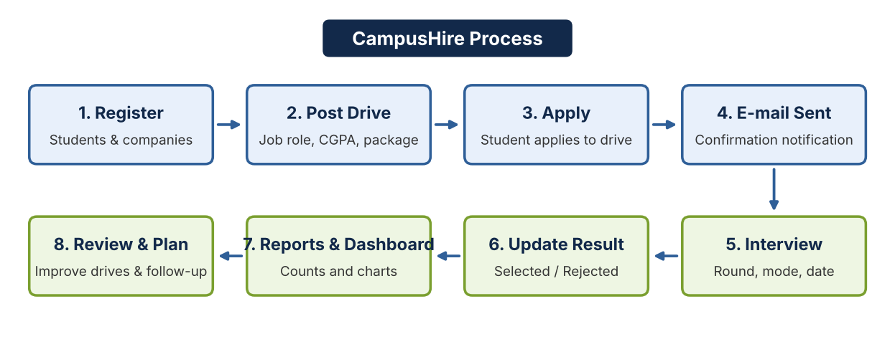
Figure 2.1: Campus placement process represented as the proposed automated workflow

2.2 Limitations of the Existing System
- Fragmented records make it difficult to see students, companies, drives and interviews in one place.
- Student information is repeated in several files and may become inconsistent.
- Eligibility details such as minimum CGPA and required skills are not stored in a structured way.
- Confirmation and notification e-mails are sent manually and may be forgotten.
- Application and interview status is not tracked consistently, so progress cannot be reviewed.
- Summary counts and charts must be prepared by hand for every review meeting.

2.3 Low-Code versus Traditional Development
Criterion | Traditional Pro-Code Development | Low-Code on Zoho Creator
Development effort | Requires custom UI, database, APIs and deployment setup. | Uses visual form, report and page builders with configured workflows.
Data capture | Forms and validation are coded individually. | Forms, picklists, lookups and mandatory fields are configured visually.
Automation | Requires application logic and job schedulers to be implemented. | Form workflows and Deluge scripts support event-driven automation.
Notifications | Requires a mail service to be integrated and maintained. | The Deluge sendmail task sends e-mail from within the platform.
Integration | Requires API clients and authentication handling. | Built-in Zoho CRM integration tasks can be called from Deluge.
Hosting | Infrastructure and release process are managed separately. | Platform hosting and application publishing are provided by the service.
Customisation | Offers broad control over architecture and UI. | Customisation is bounded by platform capabilities and plan limits.
Maintenance | Requires code-level maintenance and deployment discipline. | Routine changes are simpler, but scripts and permissions still need testing.
Table 2.1: Low-Code and Traditional Development Comparison

2.4 Literature Survey
The following sources provide the platform and process background for this project. The project brief does not include a formal research-paper survey; the table therefore focuses on authoritative platform documentation and an established security reference rather than claiming results from experiments that were not carried out.
S.No. | Source | Focus | Relevance
1 | Zoho Creator documentation [1] | Forms, reports, pages and application building | Primary reference for platform capabilities.
2 | Zoho Deluge documentation [2] | Scripting language, fetch, insert and sendmail tasks | Supports the e-mail notification logic.
3 | Zoho Creator workflow documentation [3] | Event-based form workflows | Relevant to the add and success triggers used in CampusHire.
4 | Zoho Creator pages documentation [4] | Dashboard pages, count cards and charts | Relevant to the CampusHire dashboard.
5 | Zoho CRM API documentation [5] | Lead creation through the CRM integration task | Relevant to the student lead workflow.
6 | OWASP Application Security Verification Standard [6] | Application security controls | General checklist for access and data protection.
Table 2.2: Literature Survey Summary

2.5 Emerging Trends in Low-Code Development
Low-code platforms increasingly combine visual modelling, reusable components, event-driven automation, integrations and analytics. For CampusHire, these patterns support a single data model, automatic notifications and dashboard reporting. Automated checks should still be designed carefully: workflows need clear failure handling, protection against duplicate records and e-mails, role-appropriate permissions and testing with both valid and invalid records.

2.6 Proposed System
The proposed system centralises placement information in five Zoho Creator forms. Students are registered once with their academic profile, skills, resume and job preferences. Companies are registered with contact details and location, and each placement drive is linked to a registered company through a lookup field. Job applications and interviews are recorded with status, round and result fields. Each add action triggers a workflow that sends a notification e-mail, and every student record also creates a lead in Zoho CRM. Reports and a dashboard give the placement team a consolidated view of registrations, drives, interviews, placement status and application status.

CHAPTER 3
REQUIREMENT ANALYSIS

3.1 Stakeholders and User Roles
Role | Responsibilities
Student | Provides profile, skills, resume and job preferences; applies to placement drives; receives confirmation e-mails.
Placement Officer / Administrator | Registers companies, creates placement drives, records applications and interviews, updates results, and reviews reports and the dashboard.
Company Representative | Is registered through the Company form and receives a registration confirmation at the company e-mail.
System (Workflows) | Sends notification e-mails on form submission and creates a lead in Zoho CRM for each student record.
Developer | Configures forms, fields, workflows, reports and the dashboard; manages profiles and roles; reviews workflow execution history; publishes the application.
Table 3.1: Stakeholders and User Roles

3.2 Functional Requirements
ID | Requirement | Role(s) | Priority
FR-01 | Register students with name, register number, e-mail, phone, department, year, CGPA, skills, certification, resume and number of backlogs. | Student / Admin | High
FR-02 | Capture preferred job role, preferred location, internship experience, projects and placement status of each student. | Student / Admin | High
FR-03 | Register companies with e-mail, HR contact, location (with map support), industry and website. | Admin | High
FR-04 | Create placement drives linked to a registered company with job role, location, minimum CGPA, required skills, package (LPA), deadline, drive date and status. | Admin | High
FR-05 | Record job applications with student, placement drive, application date, status and remarks. | Student / Admin | High
FR-06 | Schedule interviews with student, company, job role, date, mode, round, status, result and remarks. | Admin | High
FR-07 | Send a confirmation e-mail when a student registration succeeds. | System | Medium
FR-08 | Send a registration confirmation to the company e-mail when a company is added. | System | Medium
FR-09 | Send a notification when a placement drive is created. | System | Medium
FR-10 | Send a confirmation when a job application is submitted. | System | High
FR-11 | Send a notification when an interview is scheduled. | System | High
FR-12 | Create a lead in Zoho CRM whenever a student record is added or edited. | System | Medium
FR-13 | Provide full-list and tracking reports for students, companies, drives, applications and interviews. | Admin | High
FR-14 | Provide a dashboard with registration counts, a placement status chart and an application status chart. | Admin | Medium
FR-15 | Provide a left navigation menu and device layouts for web, phone and tablet. | All | Medium
Table 3.2: Functional Requirements

3.3 Non-Functional Requirements
ID | Category | Requirement
NFR-01 | Data integrity | Lookup relationships, picklists and mandatory fields should keep linked records consistent.
NFR-02 | Security and privacy | Personal data such as names, e-mails, phone numbers and addresses should be accessible only to authenticated, permitted users.
NFR-03 | Usability | Forms, reports and the dashboard should use consistent labels, logical grouping and clear statuses.
NFR-04 | Maintainability | Workflow logic should be named, documented and tested after every change.
NFR-05 | Auditability | Workflow execution history should show when notifications and CRM calls were triggered.
NFR-06 | Availability | Application access depends on platform availability and network connectivity.
NFR-07 | Performance | Reports should be sorted and filtered appropriately for large student lists.
Table 3.3: Non-Functional Requirements

3.4 Hardware and Software Requirements
Category | Specification
Platform | Zoho Creator low-code application platform
Scripting | Deluge for form workflows, e-mail notification and CRM integration
Client | Desktop, laptop, tablet or mobile device with a modern browser and a stable internet connection
Browser | Current version of Google Chrome, Microsoft Edge or Mozilla Firefox
Development | Zoho Creator form, report, page and workflow builders
Integration | Zoho CRM (lead creation) through the built-in Deluge integration task
Regional settings | Date format dd-MMM-yyyy, 24-hour time format, time zone Asia/Kolkata
Mail delivery | Platform sendmail task using the administrator account as sender
Table 3.4: Hardware and Software Requirements

3.5 Use Case Model
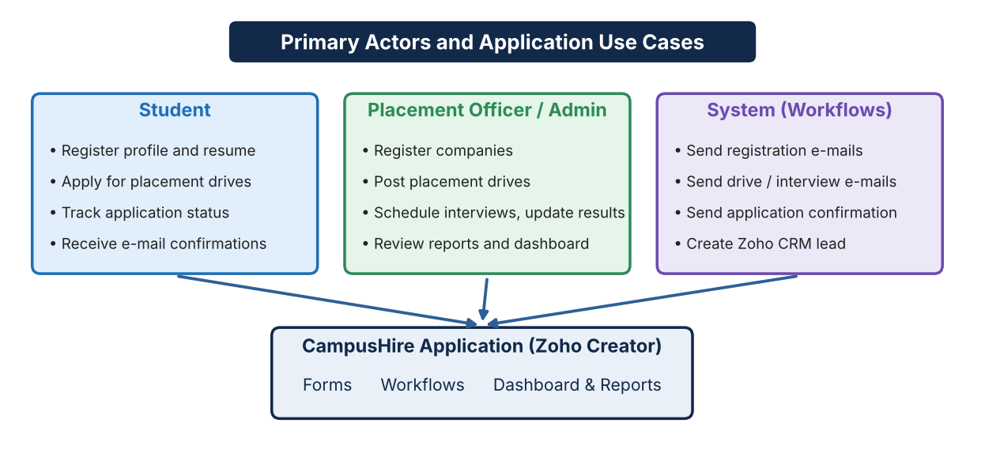
Figure 3.1: Primary actors and the CampusHire application

Use Case | Precondition | Main flow | Result
Register student | None. | Open the Student Registration form, enter profile, skills and resume, then submit. | Student is saved, a confirmation e-mail is sent and a CRM lead is created.
Post placement drive | Company is registered. | Open the Placement Drive form, choose the company, enter eligibility, package and dates, then submit. | Drive is saved and a notification e-mail is sent.
Submit job application | A placement drive exists. | Open the Job Application form, select student and drive, enter date and status, then submit. | Application is saved and a confirmation e-mail is sent.
Schedule interview | Application is shortlisted. | Open the Interview form, select student, company, round, mode and date, then submit. | Interview is saved and a scheduling e-mail is sent.
Table 3.5: Use Case Descriptions

CHAPTER 4
SYSTEM DESIGN

4.1 System Architecture

The architecture separates the user-facing layer, the workflow logic and the stored application records. The user interacts with Zoho Creator forms, reports and the dashboard page. Form workflows written in Deluge send notification e-mails and call the Zoho CRM integration. Stored records provide the operational data used by the reports and the dashboard.
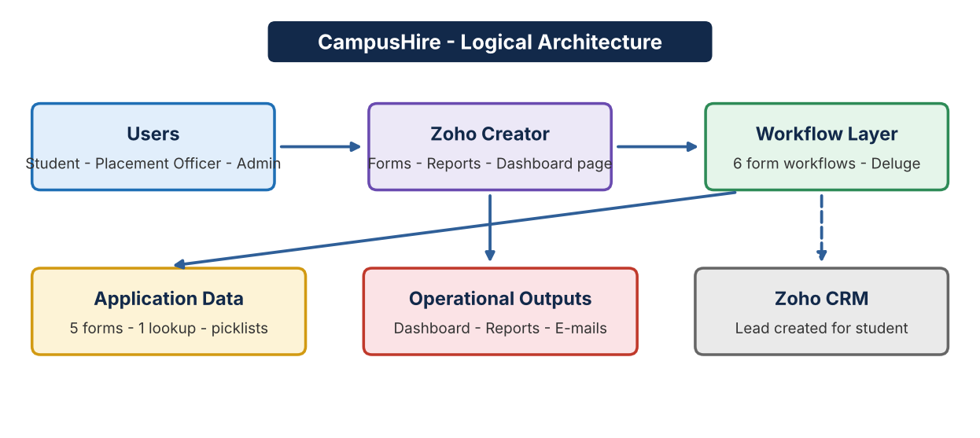

Figure 4.1: Logical architecture of the CampusHire application

4.2 Data Model
The data model contains one reference form and four transaction forms. Company acts as a master that Placement Drive refers to through a lookup field, so a company name is selected rather than typed. Student Registration holds the student profile. Job Application and Interview connect a student with a drive or company through picklist values that are stored with each record. The current version therefore uses one true lookup relationship; converting the picklist links to lookups is listed as a future enhancement.
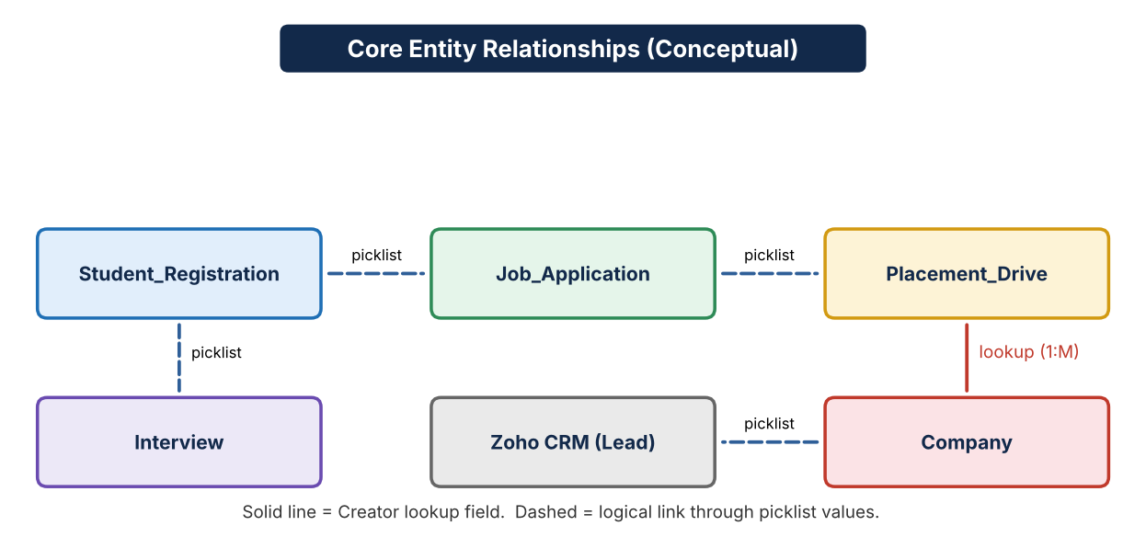
Figure 4.2: Conceptual relationships between core CampusHire entities
Entity | Relationship / Purpose
Student Registration | Stores student name, register number, contact details, department, year, CGPA, skills, certification, resume, backlogs, job preferences, internship experience, projects and placement status. A lead is created in Zoho CRM from this form.
Company | Stores company name, e-mail, HR contact, location, industry and website. One company can be referred to by many placement drives through a lookup.
Placement Drive | Stores job role, company (lookup), location, minimum CGPA, required skills, package in LPA, application deadline, drive date and drive status.
Job Application | Records a student applying to a placement drive, with application date, status and remarks.
Interview | Records the student, company, job role, interview date, mode, round, status, result and remarks.
Table 4.1: Entities and Relationships

4.3 Form Design
Form group | Design considerations
Profile forms | Student Registration and Company hold reusable student and company data. Personal fields such as e-mail, phone, name and address are marked as personal data. Company location uses an address field with map coordinates captured.
Process forms | Placement Drive, Job Application and Interview record the placement process using picklists for status, round, mode and result and date fields for deadlines and schedules.
Input controls | Picklists restrict values such as department, year, industry and placement status; multi-select lists capture skills; a file-upload field accepts up to ten resume files; CGPA is a mandatory decimal field.
Layout | Company and Student Registration use top-aligned labels, while Interview, Job Application and Placement Drive use left-aligned labels.
Table 4.2: Form Design Groups

4.4 Process and Workflow Design
CampusHire controls its records through status fields and workflows rather than through a Blueprint. Applications move through Applied, Shortliste, Interview Scheduled, Selected, Rejected and Not Selected. Interviews carry a status of Scheduled, Completed or Cancelled and a result of Pending, Selected or Rejected. Students have a placement status of Not Placed, Placed or Not Eligible, and drives carry a drive status. A Blueprint was not required because these transitions are not restricted by role; it could be introduced later if multi-user approval stages are added.
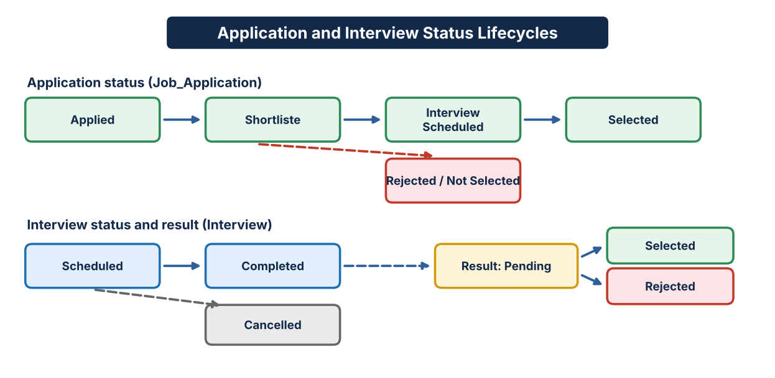
Figure 4.3: Application and interview status lifecycles in CampusHire
Every add action on a form triggers a workflow. The workflow sends a notification e-mail using the Deluge sendmail task with the administrator account as sender, and the student workflow additionally calls the Zoho CRM createLead task.

4.5 User Interface and Navigation Design
The application is organised around a left navigation menu with one section for each area: Student Registrations, Companies, Placement Drives, Job Applications and Interviews, together with App Preferences and the CampusHire Dashboard. Each section lists its form and its reports. The application uses the Lato font and the icon text "CAM". The dashboard page shows four count cards, a donut chart and a column chart. A two-column layout is used on phones and a sliding-pane layout on tablets.

4.6 Access Control Design
CampusHire relies on the default Zoho Creator profiles present in the application's share settings, together with one role named CEO that can access the data of all other users. No custom field-level or record-level restrictions are defined in the exported application. The permissions described below follow the default profile descriptions.
Role / Profile | Typical permitted actions | Restricted / controlled actions
Administrator | Full access to all components, configuration and permissions. | Privileged activity should be limited to the application owner and reviewed.
Write | Add, edit and view records in all components. | Cannot change application design or sharing configuration.
Read | View records and reports in all components. | Cannot add, edit or delete records.
Developer | Build and modify forms, workflows, reports and pages. | Should work in a development environment before publishing.
Customer (portal) | Default portal profile with add and view permission. | Not used in the current design.
CEO (role) | Can access data of all other users. | Hierarchy role only; no custom restrictions defined.
Table 4.3: Access Control Design

CHAPTER 5
IMPLEMENTATION

5.1 Application Setup
The application is named CampusHire and was built on Zoho Creator using the visual builders for forms, reports, pages and workflows. Its regional settings use the date format dd-MMM-yyyy, 24-hour time and the Asia/Kolkata time zone. Form link names such as Student_Registration, Company, Placement_Drive, Job_Application and Interview are used consistently because Deluge scripts refer to link names. The application definition was exported on 29-Oct-2026 as version 1.0.

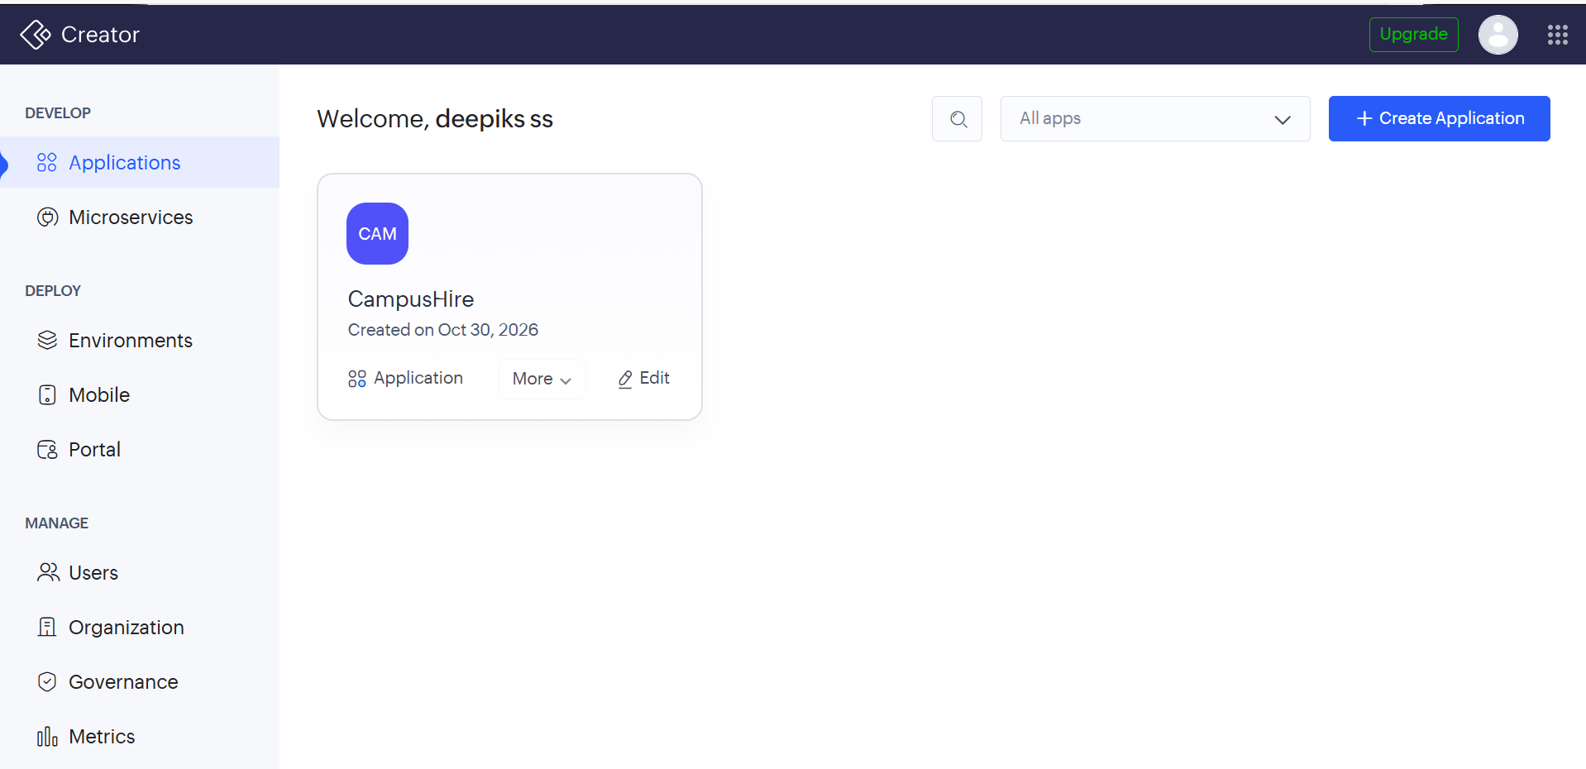
Figure 5.1: CampusHire application in the Zoho Creator workspace

5.2 Forms and Data Capture
No. | Form | Purpose and principal fields
1 | Company | Company name, e-mail, HR contact, location, industry and website.
2 | Student Registration | Student name, register number, e-mail, phone, department, year, CGPA, skills, certification, resume, placement status, preferences, internship, projects and backlogs.
3 | Placement Drive | Job role, company lookup, location, minimum CGPA, required skills, package, deadline, drive date and drive status.
4 | Job Application | Student, e-mail, placement drive, application date, application status and remarks.
5 | Interview | Student, company, job role, interview date, mode, round, status, result and remarks.
Table 5.1: Forms Implemented
5.2.1 Company form
Field | Type | Details
Company Name | Text | Name of the recruiting company.
Company Email | E-mail | Maximum 80 characters; marked personal data; recipient of the registration e-mail.
HR Contact | Phone number | Marked personal data.
Company Location | Address | Address lines, city, state, postal code, country; coordinates captured for map link.
Industry | Picklist | Finance, IT, Healthcare, Automobile, Consulting, E-Commerce, Education, Other.
Website | URL | Link name enabled.
Table 5.2: Company Form Fields

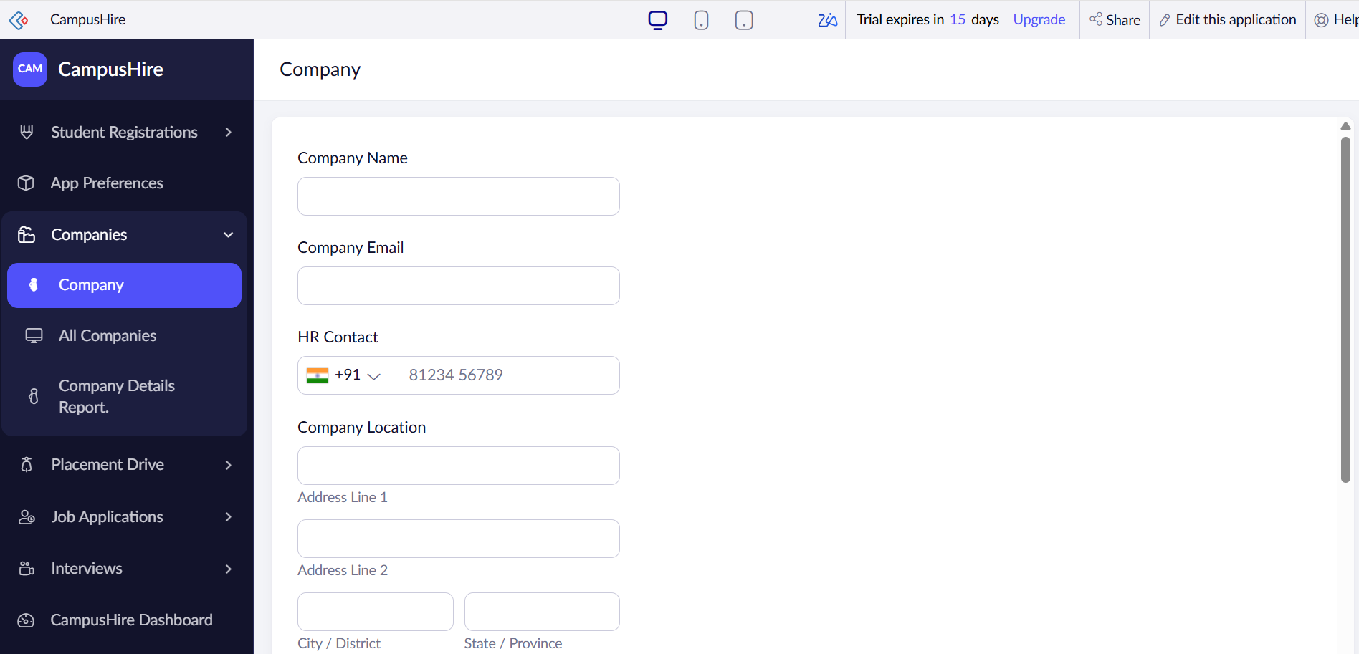
Figure 5.2: Company form in live mode
5.2.2 Student Registration form
Field | Type | Details
Student Name | Name | First and last name; marked personal data.
Register Number | Number | College register number.
Email / Phone Number | E-mail / Phone | Marked personal data.
Department | Picklist | CSE, ECE, EEE, IT, MECH, CIVIL, AIDS, AIML with an Others option.
Year | Picklist | 2nd Year, 3rd Year, 4th Year.
CGPA | Decimal | Mandatory.
Skills | Multi-select list | JAVA, CSS, C++, HTML, PYTHON, C, JAVASCRIPT, SQL, REACT, COMMUNICATION.
Certification | Multi-line text | Certifications held.
Resume | File upload | Up to ten files from the local drive.
Placement status | Picklist | Not Placed, Placed, Not Eligible.
Preferred Job Role | Picklist | Software Developer, Web Developer, Data Analyst, Software Tester, UI/UX Designer, Cloud Engineer, Cybersecurity Analyst, AI/ML Engineer, Other.
Preferred Location | Picklist | Chennai, Bangalore, Hyderabad, Pune, Mumbai, Coimbatore, Delhi, Any Location.
Internship Experience, Projects | Multi-line text | Free-text details.
Number of Backlogs | Number | Current backlog count.
Table 5.3: Student Registration Form Fields

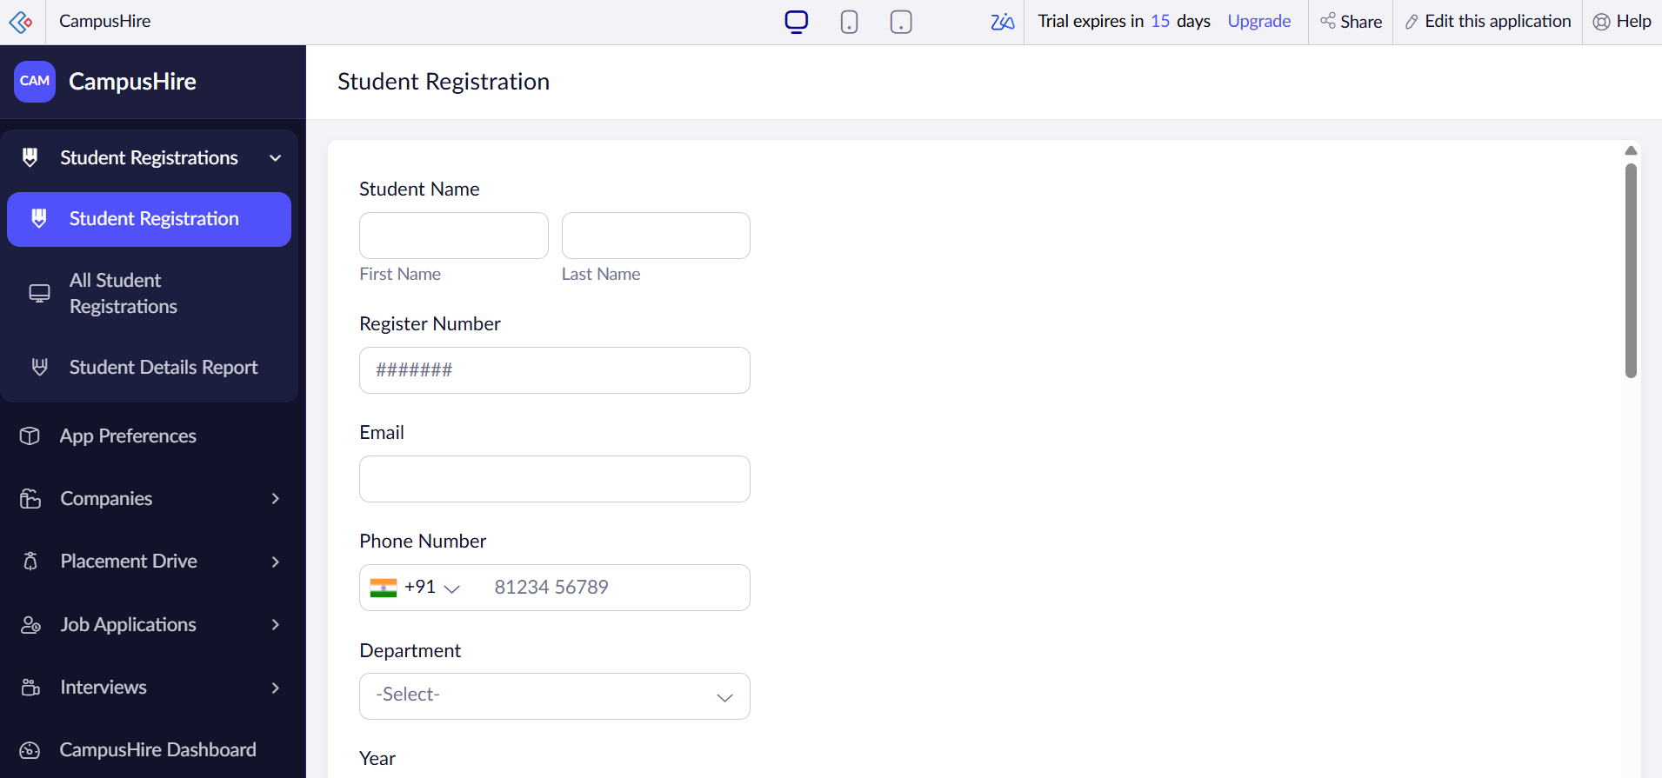

Figure 5.3: Student Registration form in live mode
5.2.3 Placement Drive form
Field | Type | Details
Job Role | Text | Role offered by the company.
Company | Lookup | Lookup to the Company form, displaying Company Name in ascending order.
Job Location | Text | Place of work.
Minimum CGPA | Number | Eligibility criterion.
Required Skills | Multi-select list | JAVA, C, C++, PYTHON, HTML, CSS, JAVASCRIPT, SQL, REACT, PROBLEM SOLVING, COMMUNICATION.
Salary Package (LPA) | Number | Package in lakhs per annum.
Application Deadline, Drive Date | Date | Last date to apply and date of the drive.
Drive Status | Picklist | Upcoming, Coming, Close, Closed, completed.
Table 5.4: Placement Drive Form Fields

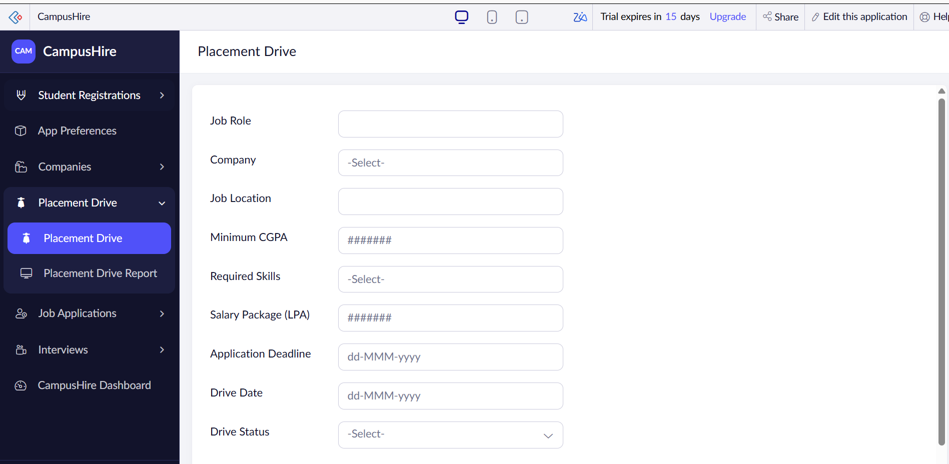
Figure 5.4: Placement Drive form in live mode
5.2.4 Job Application form
Field | Type | Details
Student (name) | Name | First and last name; marked personal data.
Student | Picklist (mandatory) | Student selected from a list of names.
Email | E-mail | Marked personal data.
Placement Drive | Picklist (mandatory) | Java Developer – TCS, Web Developer – Infosys, Data Analyst – Wipro.
Application Date | Date (mandatory) | Date of application; triggers the notification workflow.
Application Status | Picklist (mandatory) | Applied, Shortliste, Selected, Rejected, Interview Scheduled, Not Selected.
Remarks | Multi-line text | Notes on the application.
Table 5.5: Job Application Form Fields

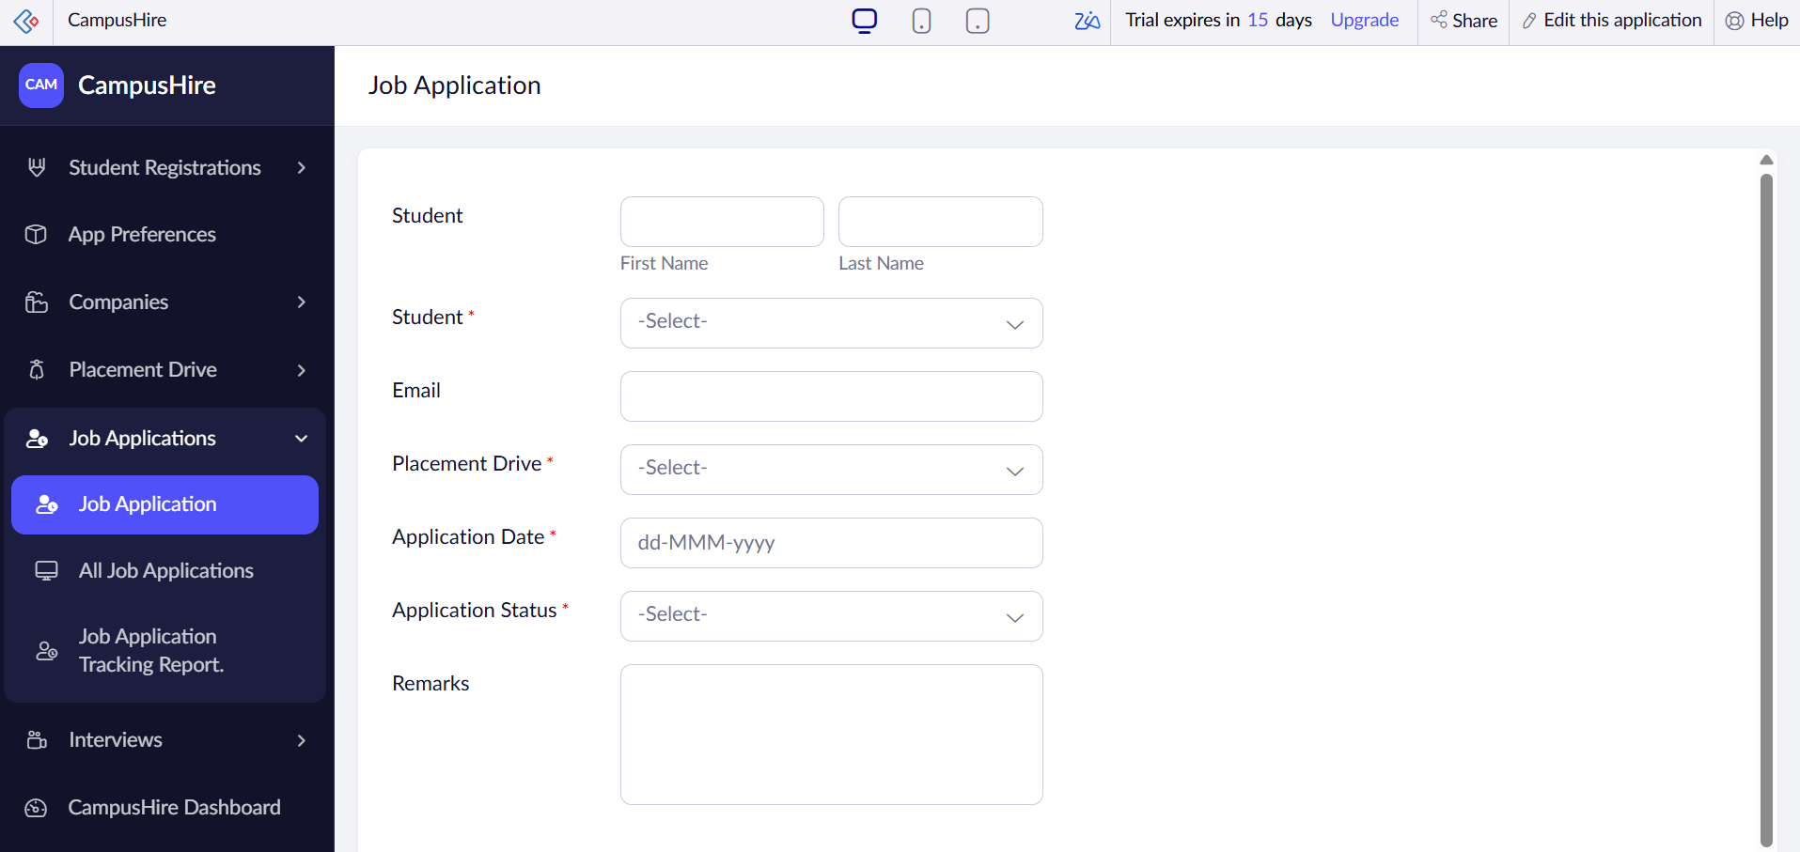
Figure 5.5: Job Application form in live mode
5.2.5 Interview form
Field | Type | Details
Student | Picklist (mandatory) | Student selected from a list of names.
Company | Picklist (mandatory) | TCS, Wipro, Infosys.
Job Role | Text (mandatory) | Role for which the interview is held.
Interview Date | Date (mandatory) | Date of the interview.
Interview Mode | Picklist | Online, Offline and one further option.
Interview Round | Picklist (mandatory) | Aptitude Test, Technical Round, HR Round, Final Round.
Interview Status | Picklist | Scheduled, Completed, Cancelled.
Result | Picklist (mandatory) | Pending, Selected, Rejected.
Remarks | Multi-line text (mandatory) | Interview feedback.
Table 5.6: Interview Form Fields

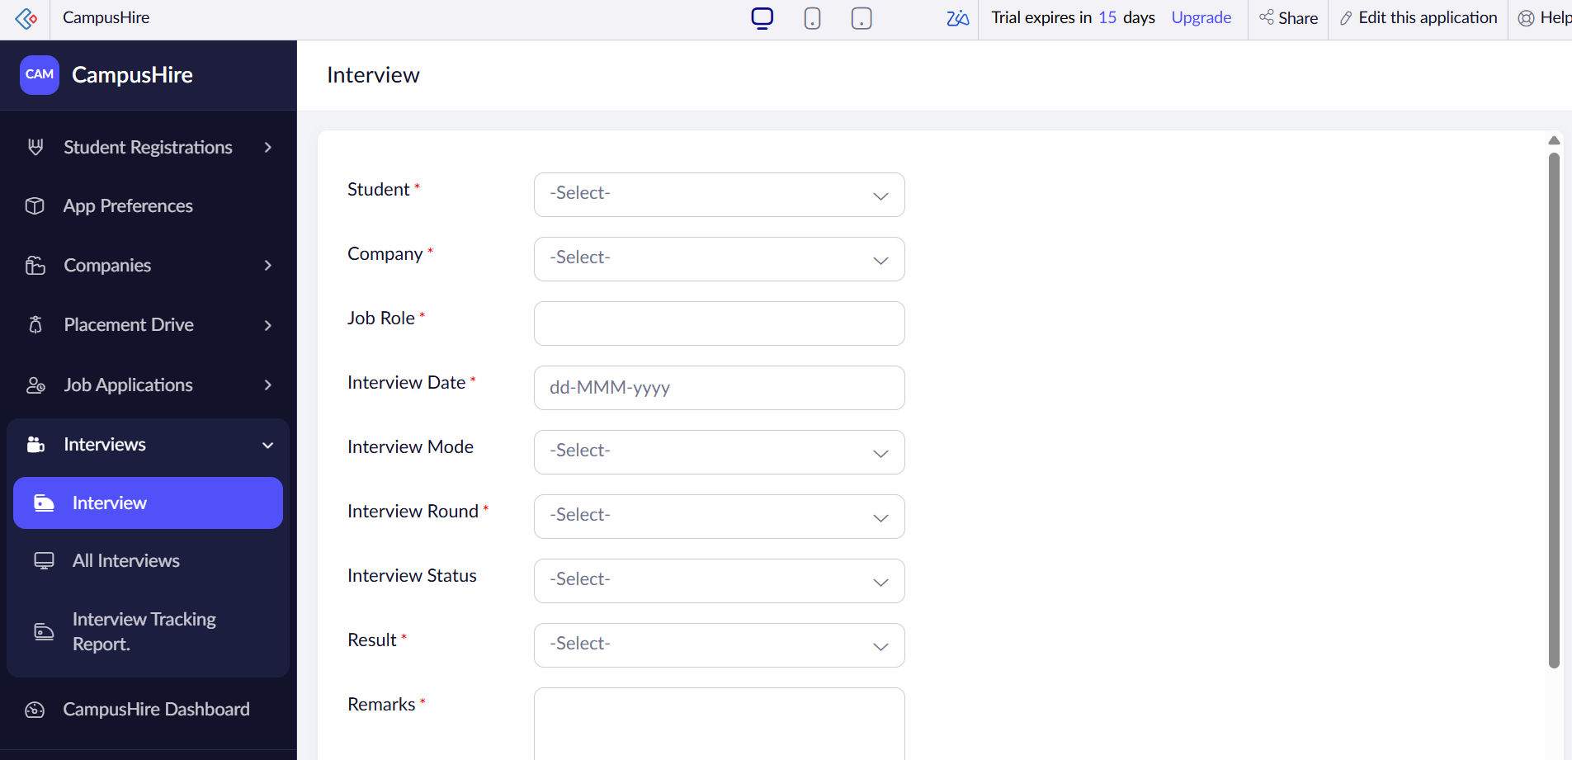
Figure 5.6: Interview form in live mode

5.3 Reports
Nine reports are defined. Five are default list reports that show all rows of a form, and four are additional tracking and detail lists. The Placement Drive Report is sorted by application deadline and the Interview Tracking Report by interview date, both in ascending order. The company reports display the location as a map link.
No. | Report | Source form | Use / criteria
1 | All Student Registrations | Student Registration | Lists all students with department, year, skills, resume, CGPA, status and preferences.
2 | All Companies | Company | Lists all companies with contact, location, industry and website.
3 | Placement Drive Report | Placement Drive | Lists drives with eligibility, package, deadline and status, sorted by deadline.
4 | All Job Applications | Job Application | Lists applications with student, drive, date, status and remarks.
5 | All Interviews | Interview | Lists interviews with round, mode, status and result.
6 | Student Details Report | Student Registration | Detailed student list for placement review.
7 | Company Details Report | Company | Company contact and location list.
8 | Job Application Tracking Report | Job Application | Tracks application status per student and drive.
9 | Interview Tracking Report | Interview | Tracks interviews sorted by interview date.
Table 5.7: Reports Implemented

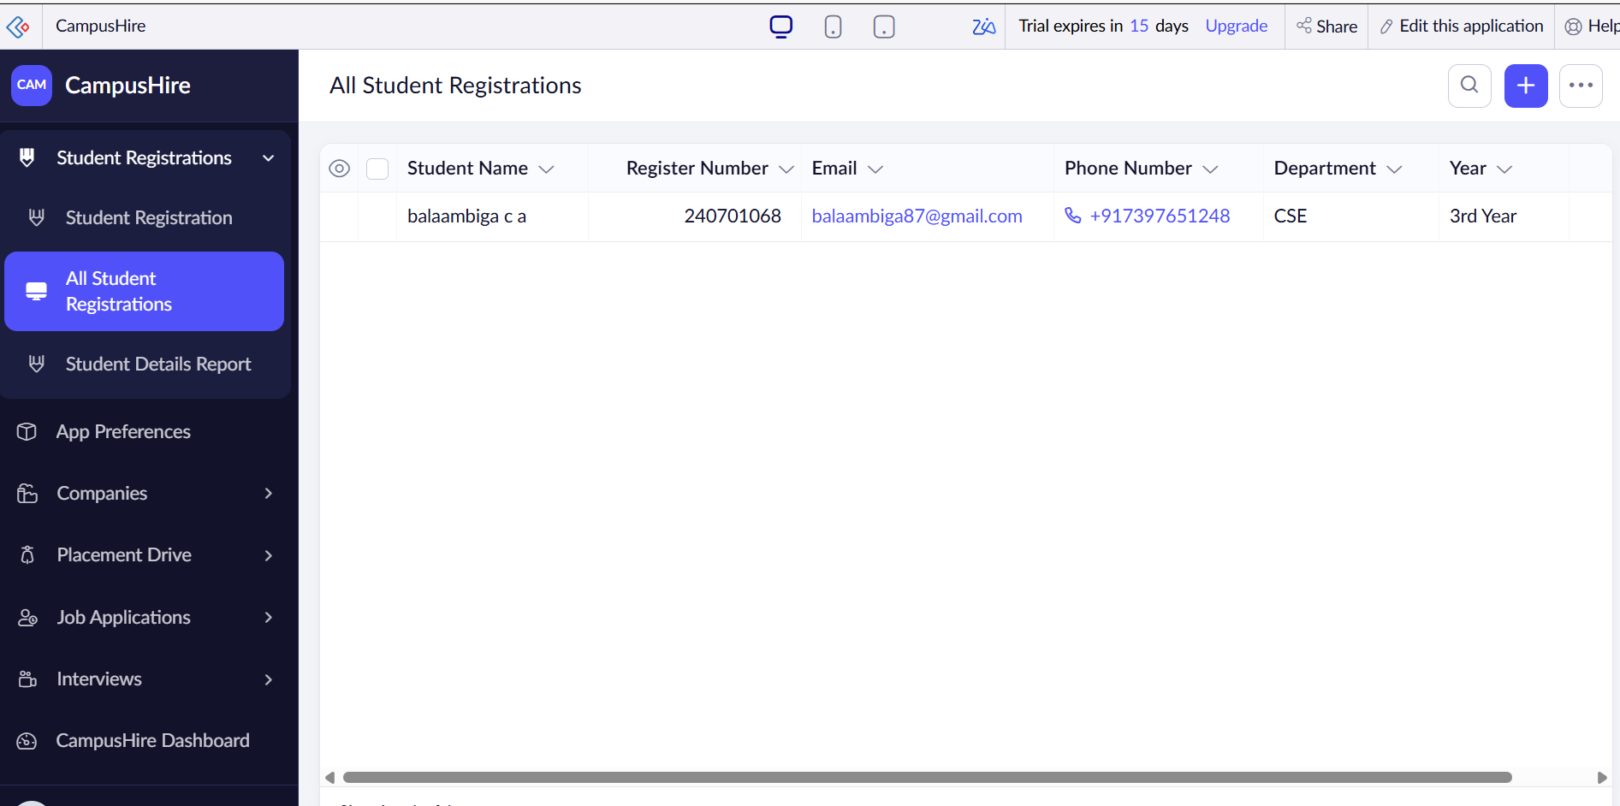
Figure 5.7: Student Details Report

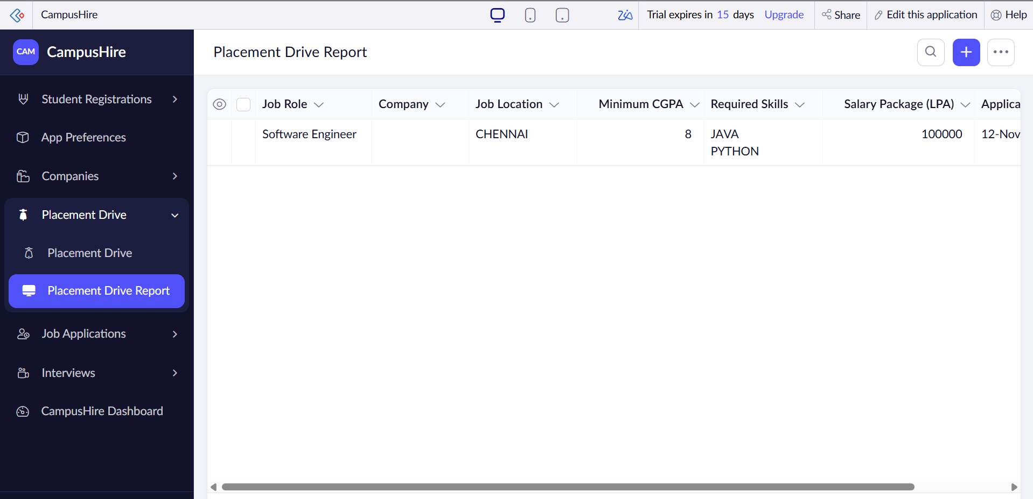
Figure 5.8: Placement Drive Report

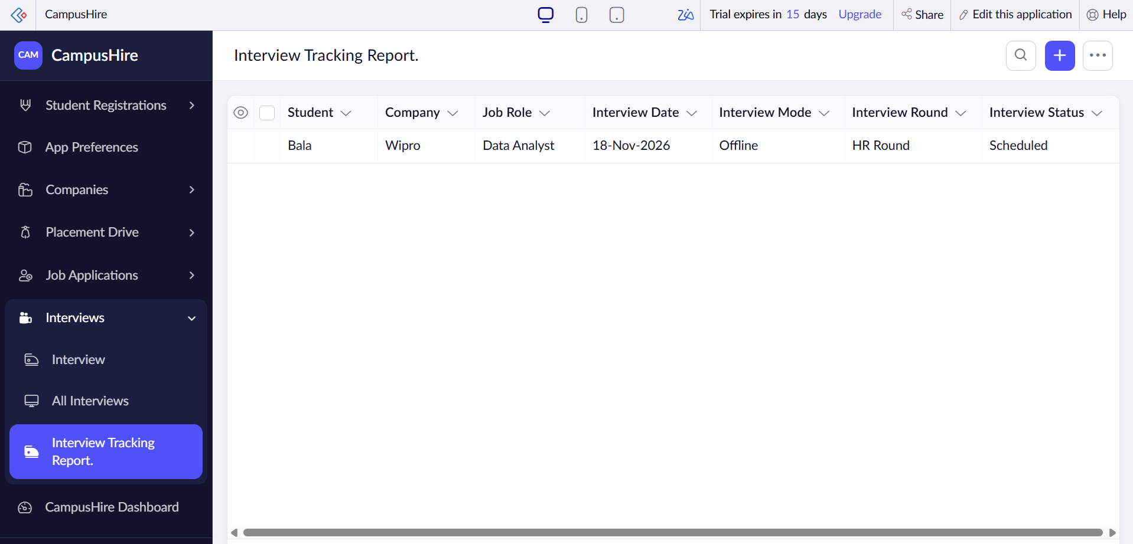
Figure 5.9: Interview Tracking Report

5.4 Pages and Dashboards
The CampusHire Dashboard page contains four count cards and two charts. The cards show Total Registered Students, Total Registered Companies, Active Placement Drives and Interviews Scheduled, each calculated as a count of records in the corresponding form. A donut chart shows the number of students by placement status, with a quick filter on placement status, and a column chart shows the number of applications by application status.

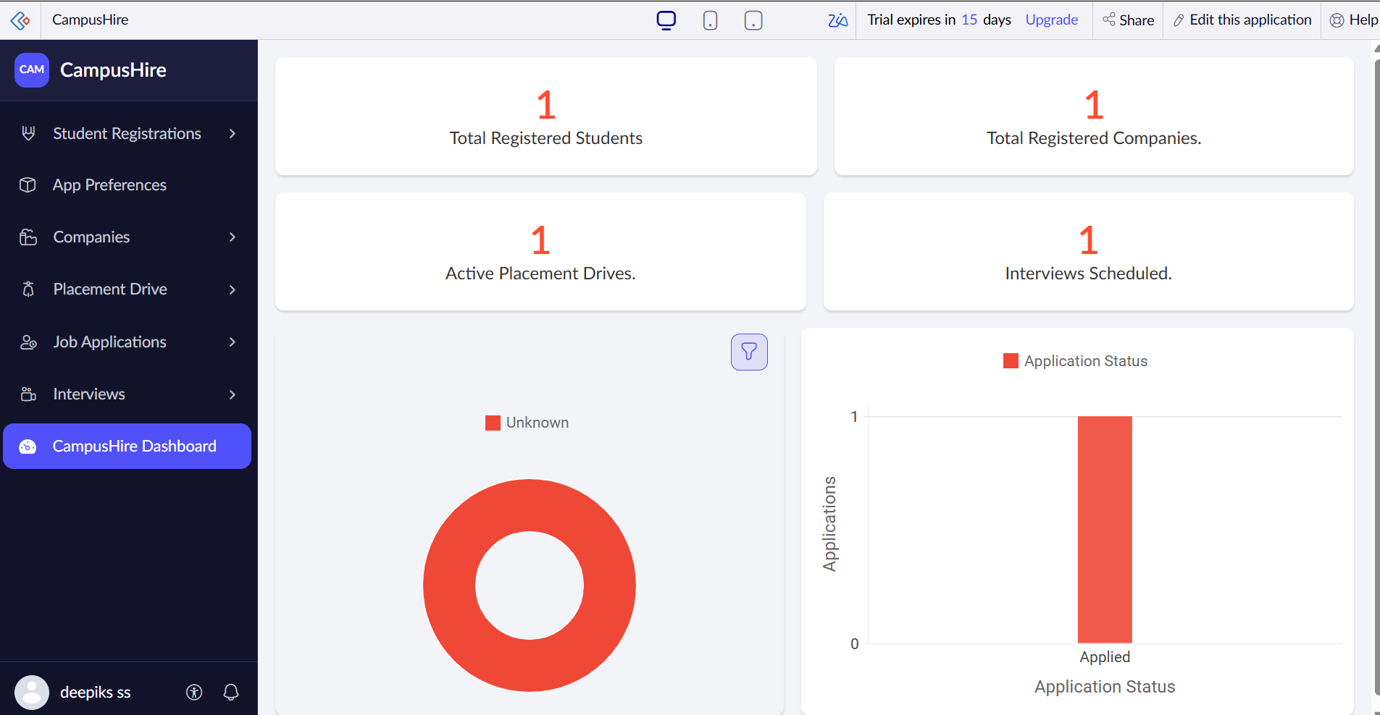
Figure 5.10: CampusHire dashboard

5.5 Deluge Scripting
Deluge is used to implement e-mail notifications and the Zoho CRM integration. The application contains six workflow scripts, each attached to the add event of its form. Table 5.8 summarises them.
No. | Trigger / Area | Logic summary
1 | Job Application – on add (user input of Application Date) | Sends the job application confirmation e-mail.
2 | Company – on add (user input of Company Email) | Sends the registration e-mail to the address entered in the Company Email field.
3 | Interview – on add (success) | Sends the interview scheduling notification.
4 | Placement Drive – on add (success) | Sends the new placement drive notification.
5 | Student Registration – on add (success) | Sends the student registration confirmation.
6 | Student Registration – on add or edit (success) | Creates a lead in Zoho CRM from the student name, e-mail and phone.
Table 5.8: Deluge Logic Summary
The e-mail and CRM scripts are shown below in condensed form; the e-mail text is shortened.
// Company Registration Notification (Company, on add)
sendmail
[
from : zoho.adminuserid
to : input.Company_Email
subject : "CampusHire - Company Registration Successful"
message : "Dear Company Representative, Thank you for registering ..."
]

// CRM (Student_Registration, on add or edit - success)
ZohoCRM.v2.createLead(data:{"Company":"Projects","Email":"Email",
"Last_Name":"Student_Name.last_name","Phone":"Phone_Number1"});
Code 5.1: Notification and CRM lead scripts

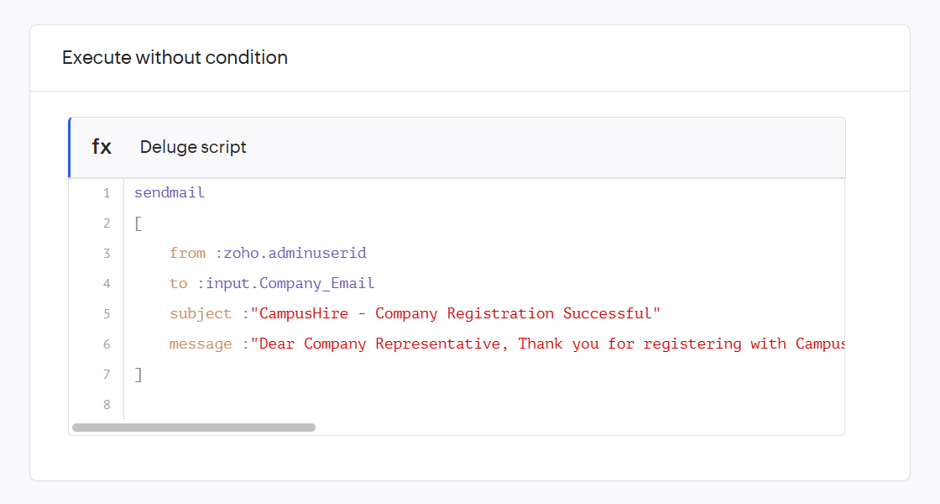
Figure 5.11: Deluge script of the Student Registration Confirmation workflow

5.6 Workflows and Automation
CampusHire uses six form workflows. They run on the add event of their forms, and the CRM workflow also runs on edit. No scheduled workflow is configured in this version, so notifications are sent immediately when a record is submitted rather than on a daily schedule.
Workflow | Type | Form | Event | Action
Job Application Submission Notification | Form | Job Application | On add – user input of Application Date | E-mail
Company Registration Notification | Form | Company | On add – user input of Company Email | E-mail
Interview Scheduling Notification | Form | Interview | On add – success | E-mail
Placement Drive Notification | Form | Placement Drive | On add – success | E-mail
Student Registration Confirmation | Form | Student Registration | On add – success | E-mail
CRM | Form | Student Registration | On add or edit – success | CRM lead
Table 5.9: Workflow Summary

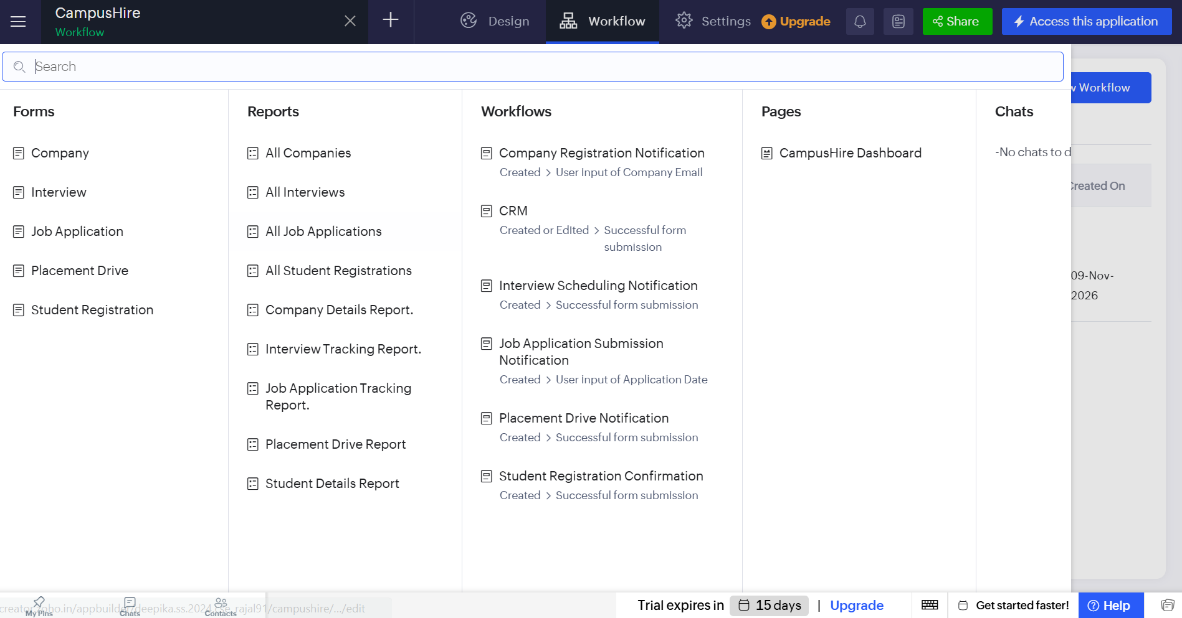
Figure 5.12: Workflow configuration of CampusHire

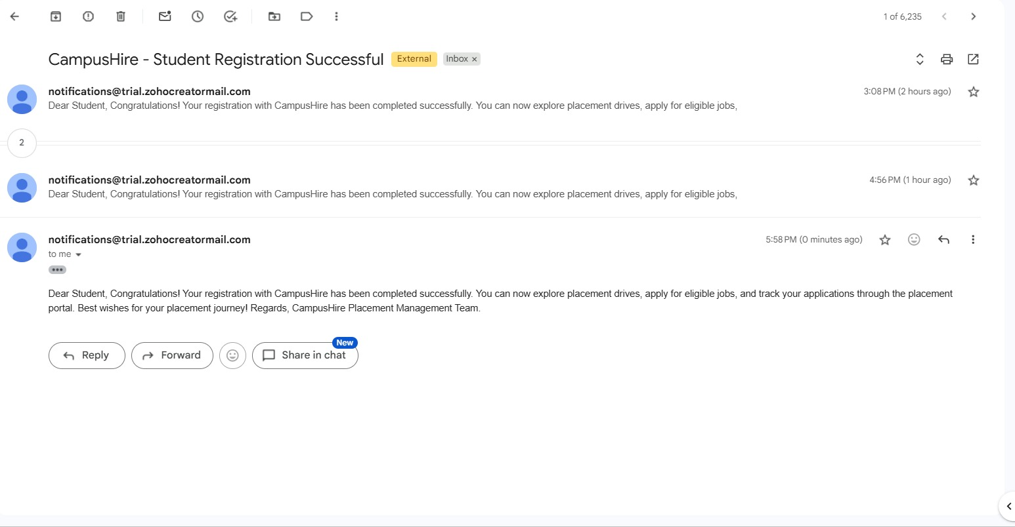
Figure 5.13: Notification e-mail received from CampusHire

Figure 5.14: Lead created in Zoho CRM

CHAPTER 6
TESTING AND DEBUGGING

6.1 Testing Strategy
Testing should cover individual field rules, workflow triggers, linked-record consistency and end-to-end scenarios. Each test should be performed with valid and invalid data, and the result should be recorded. The cases below are a practical test plan based on the implemented forms and workflows; they should be marked Pass only after execution in the live application.

6.2 Test Cases
Test ID | Area | Test input / action | Expected result | Status
TC-01 | Mandatory fields | Submit the Student Registration form without CGPA. | Submission is blocked and the field is highlighted. | To be executed
TC-02 | Student registration | Add a valid student record. | Record saved, confirmation e-mail sent and CRM lead created. | To be executed
TC-03 | Resume upload | Upload a resume file in the Student Registration form. | File is stored and visible in the report. | To be executed
TC-04 | Company registration | Add a company with a valid e-mail. | Company saved and registration e-mail sent to that address. | To be executed
TC-05 | Company location | Enter a company address and open the report. | Location is shown with a map link. | To be executed
TC-06 | Drive lookup | Create a placement drive and open the Company field. | Registered companies are listed and one can be selected. | To be executed
TC-07 | Drive notification | Submit a placement drive. | Record saved and notification e-mail sent. | To be executed
TC-08 | Job application | Submit an application with date and status. | Record saved and confirmation e-mail sent. | To be executed
TC-09 | Interview scheduling | Add an interview with round, mode and date. | Record saved and scheduling e-mail sent. | To be executed
TC-10 | Report sorting | Open Placement Drive Report and Interview Tracking Report. | Rows are sorted by deadline and interview date respectively. | To be executed
TC-11 | Dashboard counts | Add records and open the dashboard. | Count cards match the number of stored records. | To be executed
TC-12 | Dashboard charts | Add students and applications with different statuses. | Donut and column charts match the stored records. | To be executed
Table 6.1: Test Cases

6.3 Debugging Deluge Scripts
When a workflow fails, first confirm the form event and execution timing. Verify field link names, input values and e-mail addresses. Use the workflow execution history and the application logs to see what each run did. Test notification e-mails and the CRM call with valid and empty values, and check that the same event cannot run more than once and send duplicate messages.

6.4 Defect Log
The following items were identified while reviewing the exported application definition. They are recorded as points to monitor and to correct in the application.
Defect ID | Potential defect to monitor | Resolution / control | Status
D-01 | Student, company and drive names in the Job Application and Interview forms are fixed picklist values. | Replace the picklists with lookup fields to the Student Registration, Company and Placement Drive forms. | Verify in application
D-02 | Four notification workflows send to a fixed e-mail address instead of the student or administrator concerned. | Use the e-mail entered in the record or a configured administrator address. | Verify in application
D-03 | Interview Mode contains a placeholder option; Application Status contains the value "Shortliste". | Correct the picklist values to Hybrid or remove the placeholder, and to "Shortlisted". | Verify in application
D-04 | Drive Status contains overlapping values (Upcoming, Coming, Close, Closed, completed). | Standardise to Upcoming, Open, Closed and Completed. | Verify in application
D-05 | The CRM workflow maps the Projects field to the lead company and runs on every edit. | Review the field mapping and add a check to avoid duplicate leads. | Verify in application
D-06 | Minimum CGPA of a drive is not compared with the student CGPA. | Add a validation or eligibility check when an application is submitted. | Verify in application
D-07 | Remarks and Result are mandatory in the Interview form even before the interview is held. | Make Remarks optional and default Result to Pending. | Verify in application
D-08 | The Active Placement Drives and Interviews Scheduled cards count every record. | Add criteria on Drive Status and Interview Status to the counts. | Verify in application
Table 6.2: Defect and Validation Log

6.5 User Acceptance Testing
Acceptance testing should involve the placement administrator following a complete sample cycle: register a company, register a student, create a placement drive, submit a job application, schedule an interview, update the result, open the reports and dashboard, and confirm that the notification e-mails are received. Acceptance should be based on traceable records, correct totals, clear status values and received notifications. No signed acceptance sheet was supplied with the project files.

CHAPTER 7
DEPLOYMENT, SECURITY AND GOVERNANCE

7.1 Environments and Deployment Strategy
The application should be developed and tested in the development environment of Zoho Creator before it is published to the stage and production environments. A release checklist should confirm that forms, lookup relationships, Deluge scripts, workflows, reports, the dashboard and permissions are configured in the target environment. A published URL and deployment record were not supplied with the project files, so the final production deployment remains to be verified.

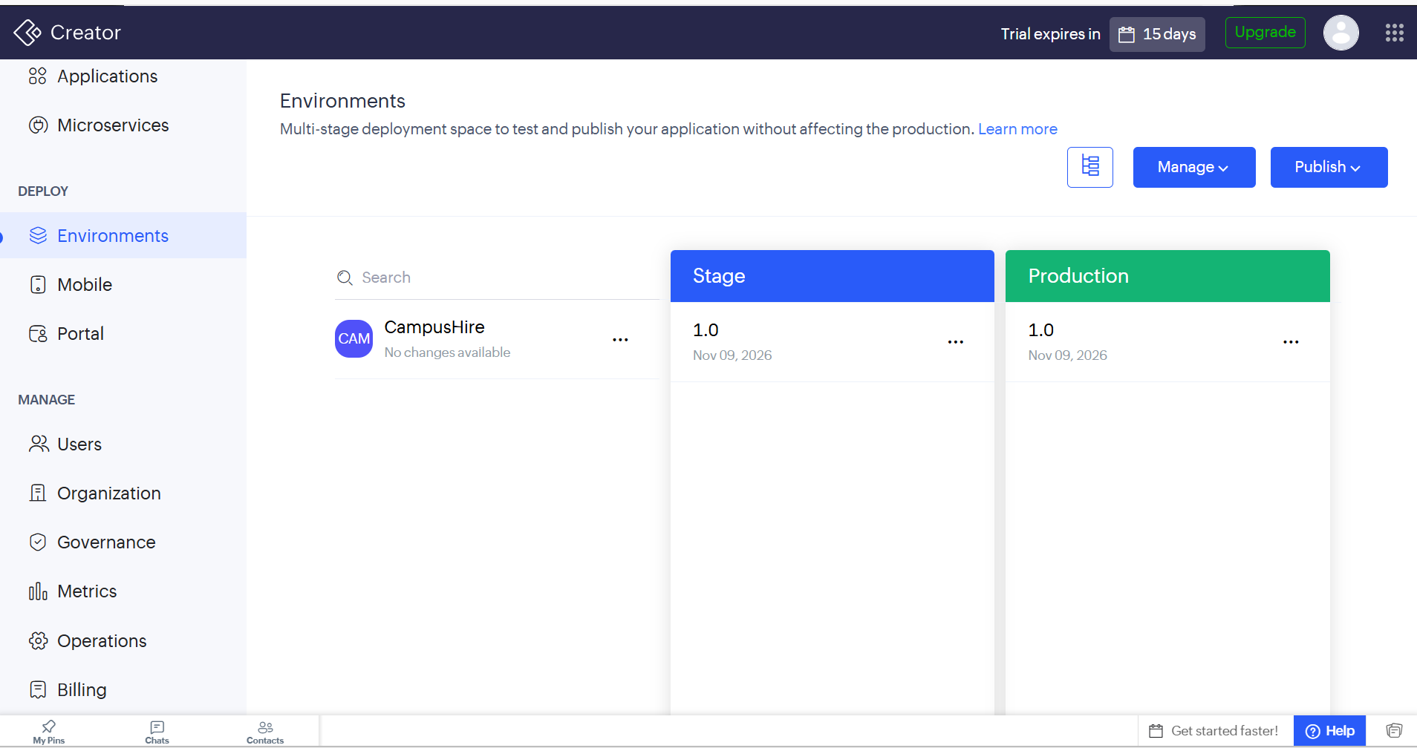
Figure 7.1: Environments
Deployment check | Verification
Data model | Confirm all five forms, field link names, the Company lookup and picklist values.
Automation | Test every workflow with sample records.
Notifications | Verify the sender account and the recipient e-mail addresses.
Integration | Confirm the Zoho CRM connection is authorised and a lead is created.
Access | Test each profile with least-privilege permissions.
Recovery | Define export, backup, recovery and change-control procedures.
Release | Record date, version, approver and known limitations.
Table 7.1: Deployment Checklist

7.2 Performance Optimisation
- Use sorted reports, as in the Placement Drive Report and Interview Tracking Report, so that the most relevant records appear first.
- Keep dashboard charts focused on decision-relevant indicators such as placement status and application status.
- Avoid duplicate workflows and unnecessary repeated updates on the same record.
- Review e-mail volume and CRM calls so that edits to student records do not create excessive processing.

7.3 Security Features
Control | Application of the control
Authentication | Access requires a Zoho account sign-in; non-public data is not exposed without authentication.
Authorisation | Profile and role permissions restrict who can add, edit, view or configure components.
Personal data marking | Student name, e-mail and phone, and company e-mail, HR contact and address fields are marked as personal data.
Validation | Mandatory fields, picklists and multi-select lists restrict invalid or incomplete entries.
Auditability | Workflow execution history and application logs show when notifications and CRM calls ran.
Error handling | The sendmail scripts do not use try and catch blocks in this version; adding them is recommended so that a failed send is recorded.
Privacy | Student and company data should be shared only with trusted users; e-mails should not include sensitive details.
Table 7.2: Security Controls Implemented

7.4 Governance and Administration
Governance for a placement application is lightweight but still important. Changes should be made in the development environment and promoted through stage to production. Workflow names should describe their purpose, as in Company Registration Notification. The exported application definition should be stored as a backup before major changes. Permissions and the e-mail addresses used for notifications should be reviewed periodically, and workflow execution history should be checked after each change.

CHAPTER 8
RESULTS AND DISCUSSION

8.1 Application Output
The application covers the placement cycle from company and student registration, through drive creation, job application and interview scheduling, to review through reports and the dashboard. The scenario below illustrates the expected behaviour in four steps.

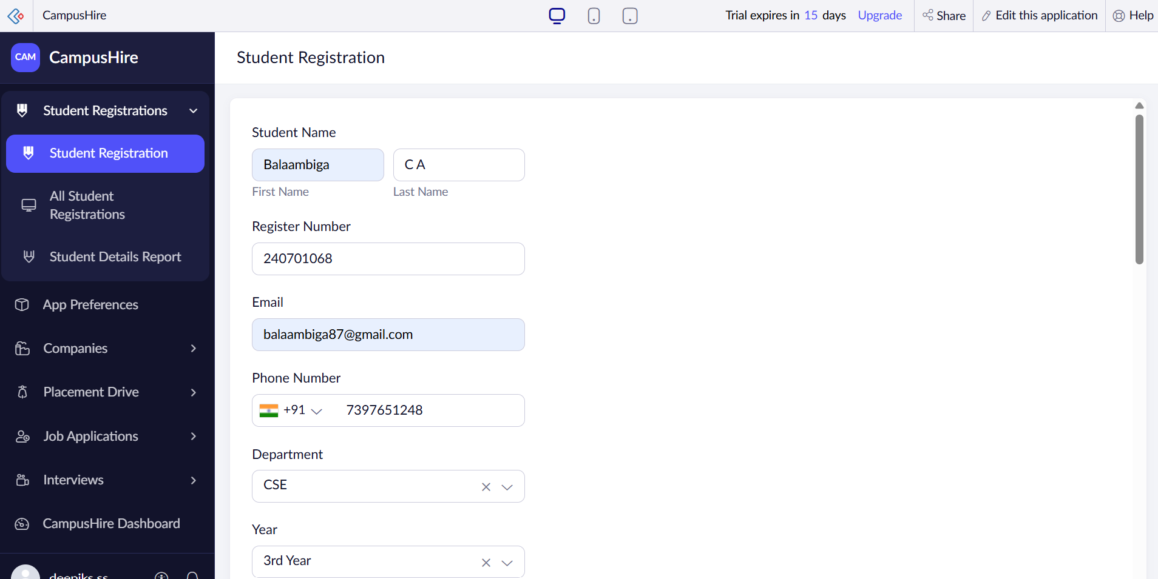
Figure 8.1: Scenario Step 1 – Registering a student

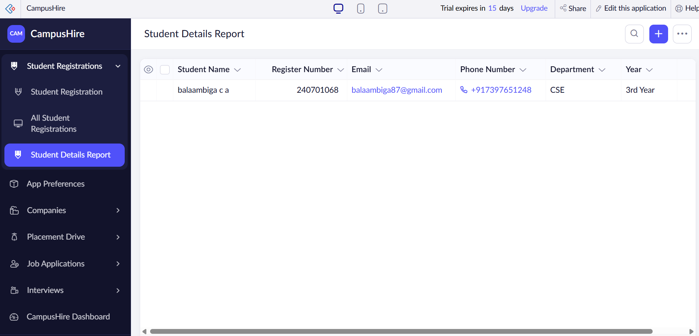
Figure 8.2: Scenario Step 2 – Student record in the report

8.2 Achievement of Objectives
Objective | Design / deliverable | Assessment
Structured forms | Five forms with a lookup from Placement Drive to Company. | Covered in the implemented design.
Student profile | Student Registration with CGPA, skills, resume and preferences. | Requires record-level test evidence.
Automation | Six form workflows (five e-mail, one CRM). | Implemented; live test evidence should be attached.
Status tracking | Application status, interview status, round and result picklists. | Requires record-level test evidence.
Management visibility | Nine reports, four count cards and two charts. | Dashboard and report availability should be verified in Creator.
Data consistency | Mandatory fields, picklists and multi-select lists. | Requires execution evidence from the live application.
Table 8.1: Objective Achievement Mapping

8.3 Comparison with the Existing System
Area | Manual / scattered process | Proposed CampusHire process
Records | Separate spreadsheets and files. | Linked records in one centralised application.
Notifications | Written and sent by hand. | Sent automatically by workflows on submission.
Eligibility data | Stated in notices. | Stored as minimum CGPA and required skills on each drive.
Tracking | Informal lists without status. | Status, round and result fields for applications and interviews.
CRM | No lead record for students. | Lead created automatically in Zoho CRM.
Overview | Prepared by hand for every meeting. | Dashboard counts, charts and sorted reports.
Table 8.2: Comparison with the Existing System

8.4 Limitations of the Low-Code Approach
The solution depends on platform availability, plan capabilities and the correct configuration of permissions, workflows and e-mail sending. Notification volume is subject to the limits of the Zoho plan in use. The current design is for an administrator who enters data: students and companies do not have separate portals, most links between forms use picklists rather than lookups, and eligibility is not checked automatically. Large datasets can require report optimisation. Low-code does not remove the need for software testing, access-control review, data-quality checks or a deployment process.

8.5 Reflection on the No-Code → Low-Code → Pro-Code Spectrum
Visual form and report builders reduce repetitive coding, while Deluge provides control over notifications and integrations. The project therefore demonstrates a low-code approach rather than a purely no-code solution.

CHAPTER 9
CONCLUSION AND FUTURE ENHANCEMENTS

9.1 Conclusion
CampusHire presents a structured low-code solution for managing campus placements in one place. Its five forms capture students, companies, placement drives, job applications and interviews, and its workflows reduce manual effort by sending notification e-mails and creating a Zoho CRM lead for every student. Nine reports and a dashboard give the placement team a consolidated view of registrations, drives, applications and interviews.
The report follows the prescribed low-code project structure and documents the requirements, design, implementation modules, testing approach, security considerations and expected outcomes. Before the report is submitted as evidence of a live deployment, the test cases should be executed and the relevant application screenshots, workflow execution logs and deployment details should be added in the marked placeholders.

9.2 Future Enhancements
- Replace the student, company and drive picklists in the Job Application and Interview forms with lookup fields.
- Check the student CGPA, backlogs and skills against the drive eligibility before an application is accepted.
- Send notifications to the student e-mail stored in the record and to a configured placement officer address.
- Add a scheduled workflow for application deadline and interview-day reminders.
- Add try and catch handling to the e-mail tasks and avoid duplicate CRM leads.
- Provide separate portals for students and companies with role-based access.
- Use Blueprint or approval stages for shortlisting and final selection.
- Add placement-percentage, department-wise and package-wise charts to the dashboard.

9.3 Learning Outcomes and Career Relevance
This project provides practical experience in requirement analysis, data modelling, form design, lookup relationships, event-driven automation, Deluge scripting, e-mail notification, CRM integration, dashboards, report design and test planning. These skills are relevant to roles in business application development, workflow automation and low-code engineering.

REFERENCES

[1] Zoho Corporation, “Zoho Creator Help Documentation,” Zoho. Available: https://www.zoho.com/creator/help/ (accessed: November 2026).
[2] Zoho Corporation, “Deluge Help,” Zoho. Available: https://www.zoho.com/deluge/help/ (accessed: November 2026).
[3] Zoho Corporation, “Workflow Rules in Zoho Creator,” Zoho Creator Help. Available: https://www.zoho.com/creator/help/ (accessed: November 2026).
[4] Zoho Corporation, “Pages in Zoho Creator,” Zoho Creator Help. Available: https://www.zoho.com/creator/help/ (accessed: November 2026).
[5] Zoho Corporation, “Zoho CRM Developer Documentation,” Zoho CRM. Available: https://www.zoho.com/crm/developer/docs/ (accessed: November 2026).
[6] OWASP Foundation, “Application Security Verification Standard (ASVS),” OWASP. Available: https://owasp.org/www-project-application-security-verification-standard/ (accessed: November 2026).

APPENDIX A
FEATURE COVERAGE CHECKLIST
Feature area | Specified / implemented in project | Evidence to attach / verify
5 forms | Yes | Screenshots of each form in Creator and sample records.
Lookup relationships | Yes (Placement Drive → Company) | Form builder screenshot and sample linked records.
Mandatory fields and picklists | Yes | Form screenshots showing required fields and picklist values.
Form workflows | 6 (5 e-mail, 1 CRM) | Workflow configuration screenshots and execution logs.
Scheduled workflow | Not used | Not applicable in this version.
Reports | 9 reports | Report screenshots with representative data.
Dashboard | 4 count cards, 2 charts | Dashboard screenshot and count checks.
E-mail notifications | Yes | Received e-mail screenshots.
Zoho CRM integration | Lead creation | Lead record screenshot in Zoho CRM.
Blueprint | Not used | Status fields and workflows control the lifecycle.
Deployment | Not evidenced in supplied files | Published URL, release date and deployment checklist.
Table A.1: Feature Coverage Checklist

APPENDIX B
REPORTS AND DASHBOARD CATALOGUE

B.1 Reports
- All Student Registrations
- All Companies
- Placement Drive Report
- All Job Applications
- All Interviews
- Student Details Report
- Company Details Report
- Job Application Tracking Report
- Interview Tracking Report

B.2 Count Cards
- Total Registered Students
- Total Registered Companies
- Active Placement Drives
- Interviews Scheduled

B.3 Charts
- Placement status of students (donut chart with quick filter on placement status)
- Applications by application status (column chart)

B.4 Scheduled Monitoring
Frequency | Monitoring activities
Daily | Review new student registrations, job applications and interviews scheduled for the day.
Weekly (recommended) | Review the Placement Drive Report for approaching deadlines and the Job Application Tracking Report for pending decisions.
Monthly (recommended) | Review the placement status chart and application status chart and update drive statuses.
Table B.1: Scheduled Monitoring

APPENDIX C
DELUGE LOGIC SUMMARY
The following summaries describe the implemented behaviour of the CampusHire workflows. Fixed recipient addresses and long e-mail text are shortened.

C.1 Job application confirmation
When a job application is added, the workflow sends a confirmation message thanking the student for applying and advising them to watch the registered e-mail for updates.
sendmail
[
from : zoho.adminuserid
to : <recipient address>
subject : "CampusHire - Job Application Confirmation"
message : "Dear Student, Thank you for applying for a job through CampusHire! ..."
]
Code C.1: Job Application Submission Notification (Job Application, on add)

C.2 Company registration e-mail
The company workflow reads the address typed in the Company Email field and sends the registration confirmation to it.
sendmail
[
from : zoho.adminuserid
to : input.Company_Email
subject : "CampusHire - Company Registration Successful"
message : "Dear Company Representative, Thank you for registering ..."
]
Code C.2: Company Registration Notification (Company, on add)

C.3 Interview, drive and student notifications
The Interview Scheduling Notification, Placement Drive Notification and Student Registration Confirmation workflows run on successful form submission and send a short message with the subjects "CampusHire - Interview Scheduled", "CampusHire - New Placement Drive" and "CampusHire - Student Registration Successful" respectively.

C.4 Zoho CRM lead creation
Whenever a student record is added or edited successfully, a lead is created in Zoho CRM using the student last name, e-mail and phone number.
ZohoCRM.v2.createLead(data:{
"Company":"Projects",
"Email":"Email",
"Last_Name":"Student_Name.last_name",
"Phone":"Phone_Number1"
});
Code C.3: CRM workflow (Student Registration, on add or edit – success)

APPENDIX D
USER MANUAL

D.1 General Access
- Open the authorised Zoho Creator application URL using a supported browser.
- Sign in with the Zoho account that has access to the application.
- Use the left navigation menu to open the form, report or dashboard you need.
- Enter the mandatory fields, verify picklist and lookup selections, and save the record.
- Use the status fields and reports to monitor progress; do not create duplicate records to retry a failed action.

D.2 Setting Up
- Open the Company form and register each visiting company with a valid e-mail address.
- Open the Student Registration form and register students with their profile, skills and resume.
- Open the Placement Drive form, choose the company and enter the eligibility, package and dates.

D.3 Daily Use
- Record each job application with the student, drive, date and status; update the status as the process moves on.
- Schedule interviews with round, mode and date; update the interview status and result after each round.
- Update the placement status of students who have been selected.

D.4 Review and Administration
- Open the CampusHire Dashboard to see the registration counts and the placement and application status charts.
- Open the Placement Drive Report to review deadlines and the Interview Tracking Report to plan the interview days.
- Administrator: test workflow changes in a safe environment and review profile permissions periodically.

D.5 Troubleshooting
Issue | Recommended check
Notification e-mail not received | Check the recipient address, the spam folder, the workflow status and the execution history.
Company cannot be selected in a drive | Confirm that the company is registered in the Company form.
CRM lead not created | Check that the Zoho CRM connection is authorised and review the execution history.
Dashboard shows no values | Check that records exist in the forms and refresh the page.
Resume not visible | Check that the file was uploaded and the field is shown in the report.
Table D.1: Troubleshooting

APPENDIX E
EVALUATION RUBRIC
Student Name | BALAAMBIGA C A | Register No. | 2116240701068
Project Title | CampusHire - Campus Placement Management System | Date

S.No. | Criterion | Indicators | Max. Marks | Marks Awarded
1 | Problem Definition & Requirement Analysis | Clarity of problem, measurable objectives, complete FR/NFR, use cases | 10
2 | System Design | Architecture, ER/data model, form specifications, workflow design, permission matrix | 10
3 | Forms, Reports & Pages | Variety of field types, lookups/subforms, report types, UI Builder dashboards | 15
4 | Deluge Scripting & Workflows | Correctness and depth of scripts; form, schedule, approval, Blueprint, batch workflows | 15
5 | Integration, RBAC & AI | Zoho/external integrations, connections, roles & permissions, Zia/analytics | 10
6 | Testing, Deployment, Security & Governance | Test coverage, environments, optimisation, security controls, audit | 10
7 | Live Demonstration | End-to-end working of the application across roles; feature checklist verified | 15
8 | Project Report | Adherence to template and format, clarity, figures, references | 5
9 | Viva-Voce | Understanding of the platform, design decisions and low-code concepts | 10
 | TOTAL |  | 100
Table E.1: Evaluation Rubric for the Individual Project
Level | % of Max. Marks | Descriptor
Excellent | 90–100 | Feature implemented completely, correctly and beyond the basic requirement; student explains design choices confidently.
Good | 70–89 | Feature implemented correctly with minor gaps; explanation adequate.
Satisfactory | 50–69 | Feature partially implemented or works only for the main path; limited explanation.
Needs Improvement | < 50 | Feature missing, non-functional or not understood by the student.
Table E.2: Performance Level Descriptors

Signature of Internal Examiner: Signature of External Examiner:
Name: ___________________ Name: ____________________

APPENDIX F
VIVA-VOCE RECORD SHEET
Student Name | BALAAMBIGA C A | Register No. | 2116240701068
Department / Section | Computer Science and Engineering | Date of Viva
Application URL Verified | Yes / No | Demo Duration | ______ min

Q.No. | Question / Topic Asked | Unit | Response (E / G / S / NI) | Remarks
1
2
3
4
5
6
7
8
Table F.1: Viva-Voce Questions and Responses
E – Excellent G – Good S – Satisfactory NI – Needs Improvement
Component | Max. Marks | Marks Awarded
Criteria 1–8 (Appendix E) | 90
Viva-Voce | 10
TOTAL | 100
Table F.2: Marks Summary
Examiners’ Remarks: ______________________________________________________________________________________________________________________________________________________

INTERNAL EXAMINER  Name: ___________________________ | EXTERNAL EXAMINER  Name: _____________________________

